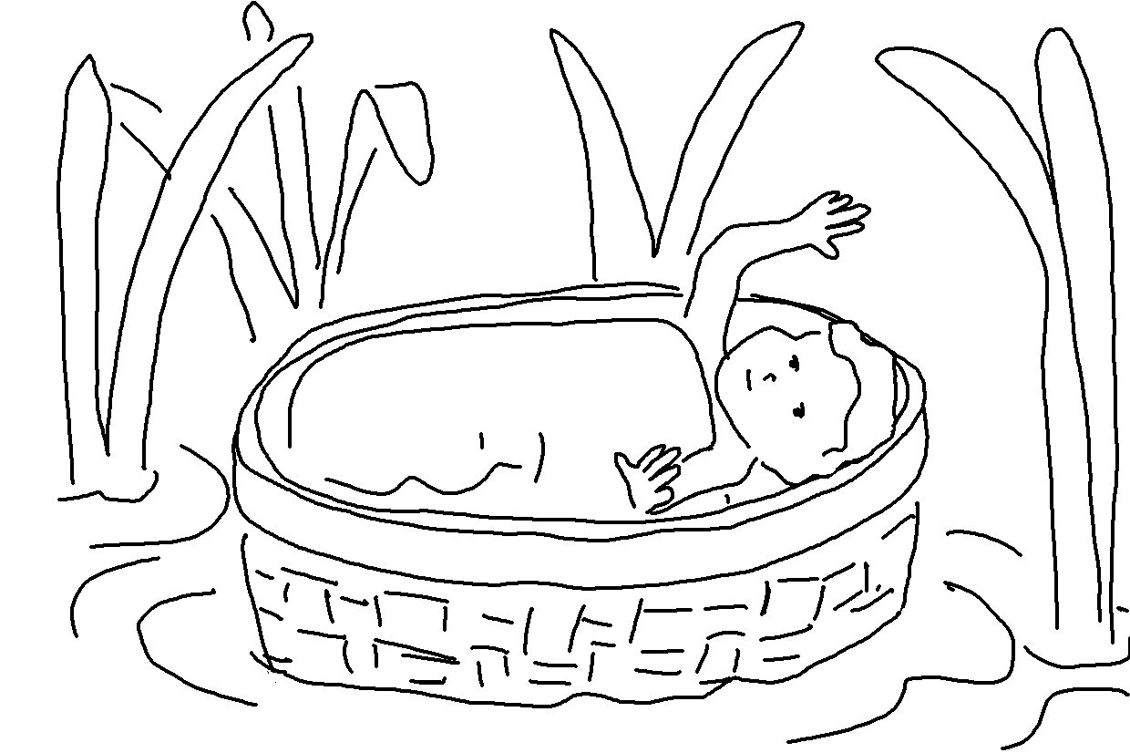
The Lord is for me, so I will have no fear. Psalms 118:6_{NLT}

